Machine Learning Project

Saloni Mehra

Student ID: 1713101367

School of Computer Science

Submitted to: Mrs. Soffia Pillai

School of Computer Science

Galgotias University, Greater Noida, U.P, 203201.

Abstract

In this project, we were asked to experiment with a real world dataset of covid-19, and to explore how machine learning algorithms can be used to find the patterns in covid-19 chest x-ray images . We were expected to predict whether a chest x-ray image shows covid-19 disease or not and were expected to submit a report about the prediction and the algorithms used. After performing the required tasks on a dataset of my choice, herein lies my final report.
Keywords: Machine Learning, Data Extraction, Convolutional Neural Network, Supervised learning, Artificial Intelligence.

Problem Statement
- Predict positive Covid -19 cases from given chest X-ray or CT scan as input image.
- Dataset contains the following columns :
Patientid,offset,sex,age,finding,survival,intubated,intubation_present,went_icu,in_icu,needed_supplemental_O2,extubated,temperature,pO2_saturation,leukocyte_count,neutrophil_count,lymphocyte_count,View,Modality,date,location,folder,filename,doi,url
- Aim is to find most appropriate model with high accuracy in predicting positive covid-19 cases from chest X-ray or Ct- scan.

Data Cleaning
- Data Cleaning is the 1st step preferred in building machine learning model.
- It is used to avoid error due to unnecessary columns in the dataset during experiment and to be clear about which column we are taking under consideration.
- I was examining the data set and found only “findings”, “folder”, “filename” and “view” column as useful columns.
- By accessing these column I made separate directory of diseases and put respective images into their directories.

categories=df.finding.unique()
print(categories)
['COVID-19' 'ARDS' 'SARS' 'Pneumocystis' 'Streptococcus' 'No Finding' 'Chlamydophila' 'E.Coli' 'COVID-19, ARDS' 'Klebsiella' 'Legionella']

Data Labeling
- Each image is labeled with its respective disease according to “finding” column.
- Saving in the format of array under list named “training_data” .
- Reading each image in array format and saving it into pickle format as X
- Reading label of each image and saving it into pickle format as Y
- These pickle will be used later while training model and validating dataset

X = [] #features
y = [] #labels

for features, label in training_data:
#print(features.shape)
X.append(features)
y.append(label)

X = np.array(X).reshape(-1, IMG_SIZE, IMG_SIZE)

print(X.shape)

(397, 50, 50)

Model
- For analysing and extracting features from image I preferred to use “Convolutional Neural Network”.
- It is a Deep Learning algorithm which takes input image in numpy array format or as tensors and assign learnable weights and biases to various parts of images such that it can differentiate among features.
- Another model used in experiment is “Multilayer Perceptron”.
- It is a feed forward Artificial Neural Network.

Convolutional Neural Network

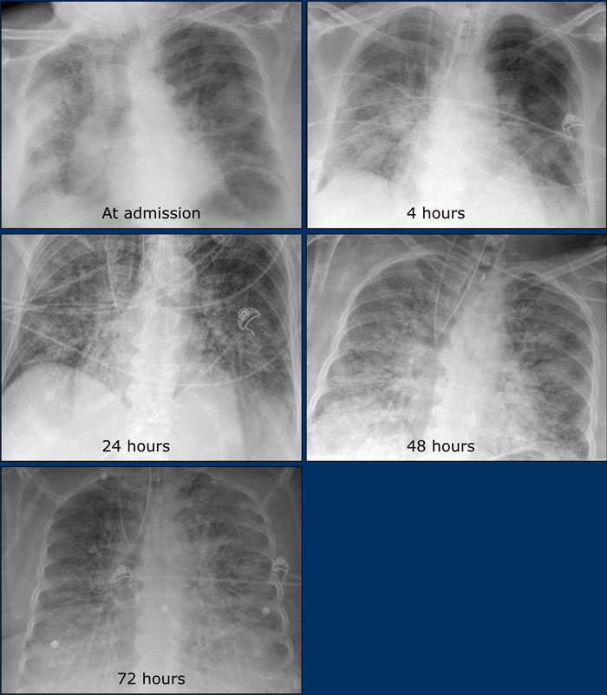

- Model 1(CNN)
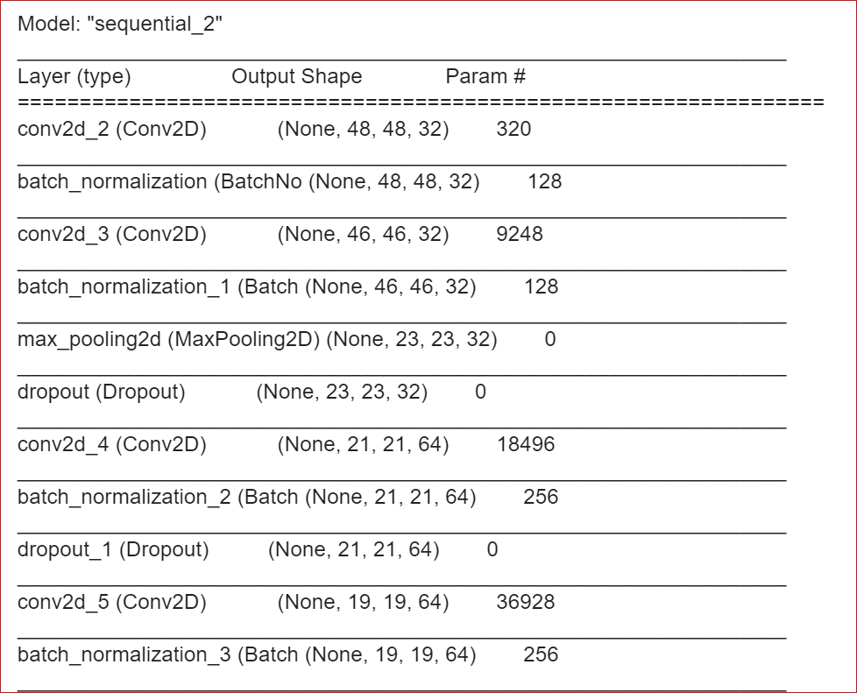
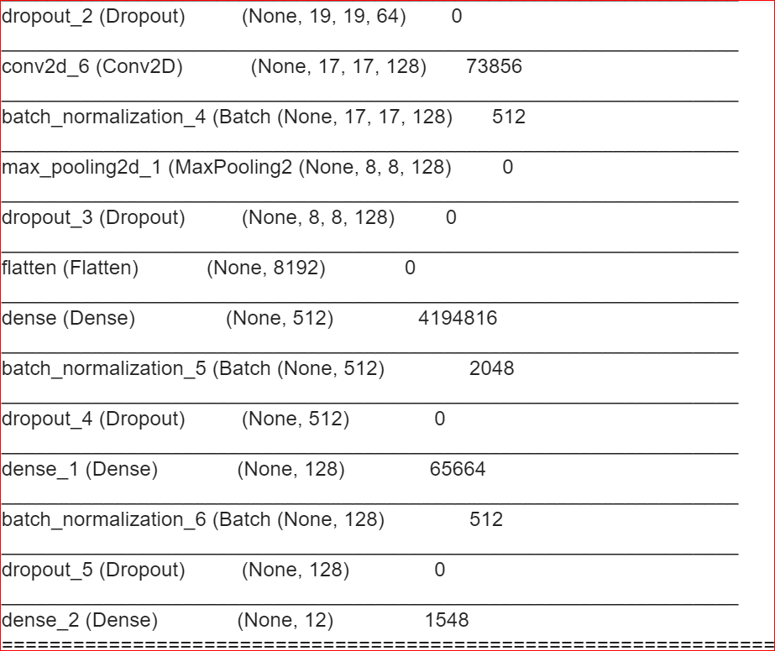
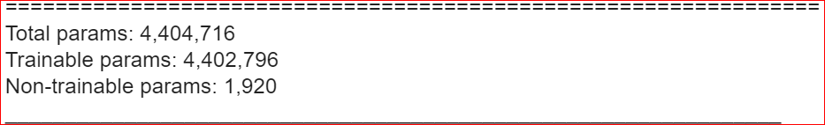

- Model 2 (CNN)

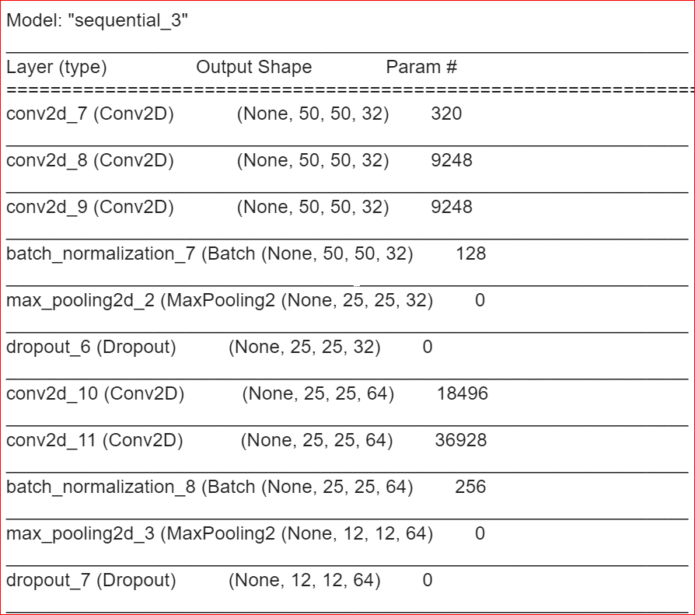
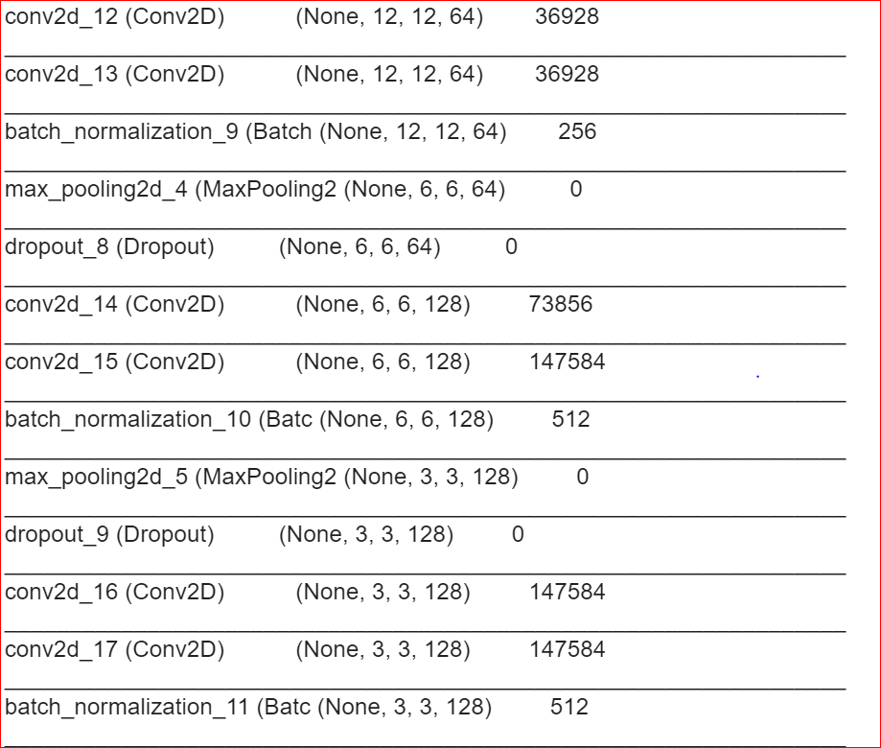
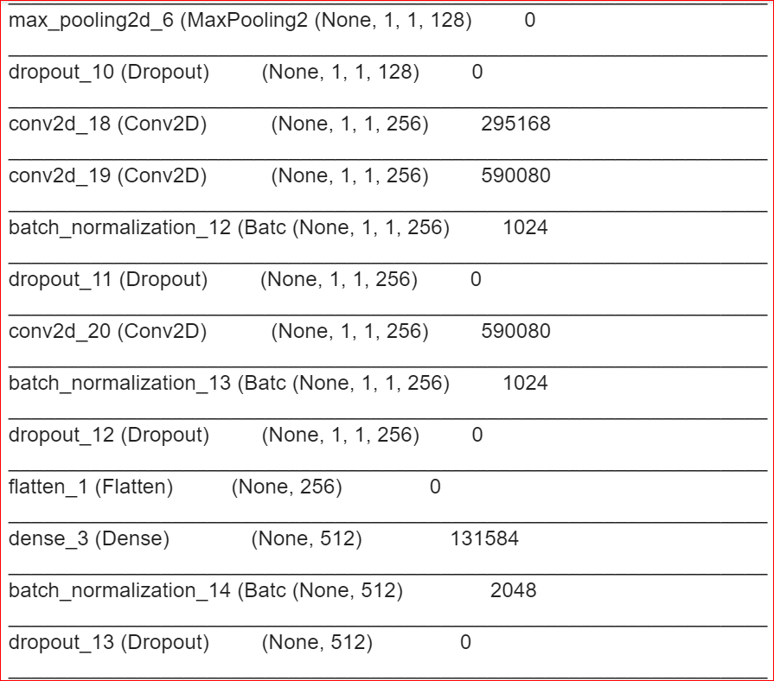
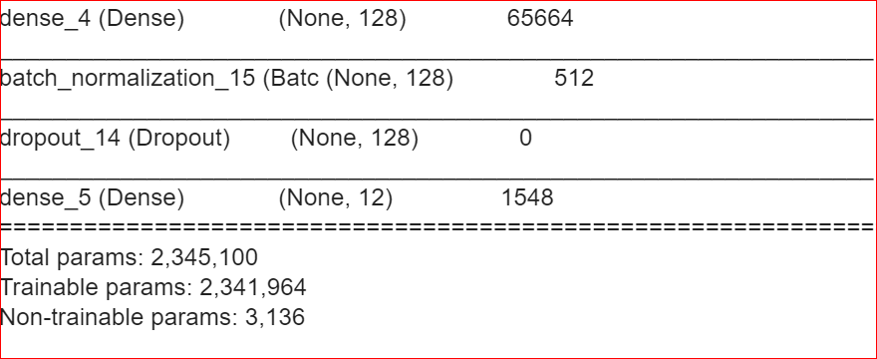

Multilayer Neural Network

- Model 3 (MLP)

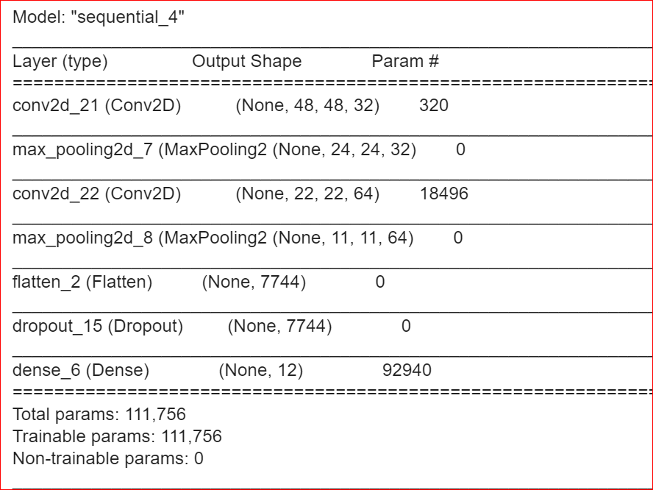

Evaluation
Model Table
Batch=15
Epochs =100

Type of Model | loss | accuracy | Val_loss | Val_accuracy
CNN  Model 1 | 0.5295 | 0.8291 | 0.8451 | 0.8500
CNN  Model 2 | 0.0875 | 0.9720 | 0.9381 | 0.7750
MLP  Model 1 | 0.0760 | 0.9720 | 1.7881 | 0.7750

Comparison
Type of Model | Graph
CNN  Model 1 | 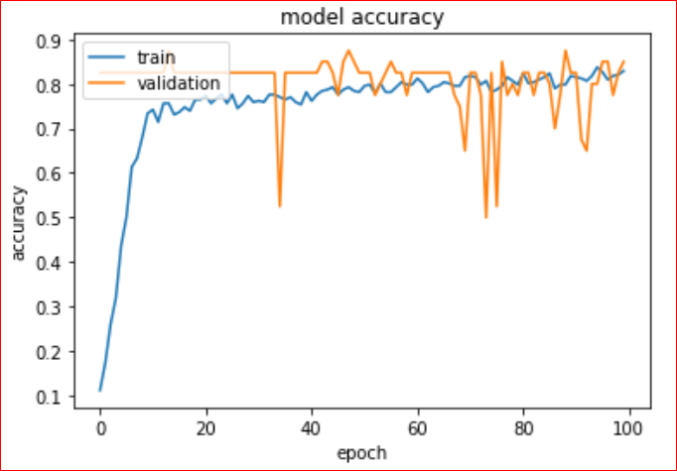
CNN  Model 2 | 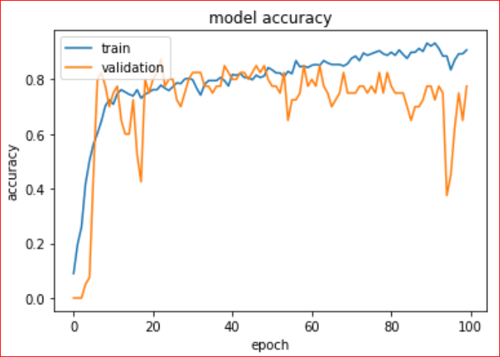
MLP  Model 1 | 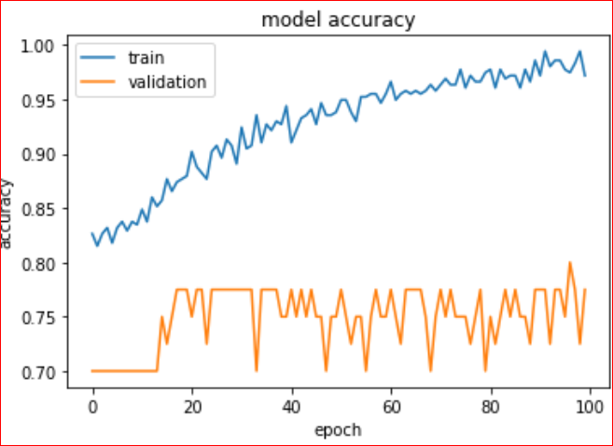

Result
Type of Model | Testing Image (covid-19 disease)
CNN  Model 1 | [[1. 0. 0. 0. 0. 0. 0. 0. 0. 0. 0. 0.]] You have SARS disease
CNN  Model 2 | [[0. 0. 1. 0. 0. 0. 0. 0. 0. 0. 0. 0.]] You have COVID-19 disease
MLP  Model 1 | [[0. 0. 0. 1. 0. 0. 0. 0. 0. 0. 0. 0.] [1. 0. 0. 0. 0. 0. 0. 0. 0. 0. 0. 0.] [0. 0. 0. 1. 0. 0. 0. 0. 0. 0. 0. 0.]] You have Pneumocystis disease You have COVID-19 disease You have Pneumocystis disease

Conclusion
- CNN Model 2 and MLP Model worked well on tested input images .
- Where CNN Model 2 is Deep Learning Model and predicts only 1 class
- MLP Model is Multilayered Neural Network and predicts 3 classes having probability greater than 0.5 .
- CNN Model 1 fails to recognize minute features in the image thus accuracy is decreased.

